Framework Design Specification

A report describing the detailed design requirements for the Network Appliance Service Utilisation Framework

Version: 0.1a

By

Paul Fergus

Supervised by

Dr. Martin Hanneghan and Prof. Madjid Merabti

Networked Appliances Lab
School of Computing and Mathematical Sciences
Liverpool John Moores University

Table of Contents

Table of Contents ii
1 Introduction 2
1.1 Sections 2
1.2 Release Information 2
1.3 Reader Level 2
1.4 Terminology and Conventions used 2
1.4.1 Typography 2
1.4.2 Object Oriented Terminology 2
1.4.3 Diagrams 2
1.4.4 Keywords 2
1.5 The Specification Process 2
1.6 Version Information 2
1.7 Compliance Programs 2
1.8 Compliance Claims 2
2 Framework Specification 2
2.1 Introduction 2
2.2 Starting the Framework 2
2.3 Shutting the Framework down 2
2.4 Network 2
2.5 Services 2
2.5.1 Releasing Services 2
2.5.2 Un-registering Services 2
2.6 Descriptions 2
2.7 Discovery 2
2.8 Semantic Service Capability Matching 2
2.9 Control 2
2.9.1 Event Handling 2
2.10 Presentation 2
2.11 Security 2
3 Network 2
3.1 Design Requirements 2
3.1.1 Interoperability 2
3.1.2 Platform Independence 2
3.1.3 Ubiquity 2
3.1.4 Device Independence 2
3.2 Transport Layer 2
3.2.1 TCP/IP 2
3.2.1.1 Broadcasting 2
3.2.2 HTTP 2
3.2.3 Bluetooth 2
3.3 Virtual Network 2
4 Services 2
4.1 Peer Services 2
4.2 Group Services 2
5 Descriptions 3
5.1 Design Requirements 3
5.2 Semantic Mark-up Language 3
5.3 Requests 3
5.3.1 Device requests 3
5.3.2 Service requests 3
5.4 Device Descriptions 3
5.5 Service Descriptions 3
5.5.1 Writing Service Descriptions 3
6 Discovery 3
6.1 Groups 3
6.2 Peer Groups 3
6.3 Discovery Mechanisms 3
6.3.1 Discovery Service 3
6.3.2 Message Service 3
6.3.3 Pipe Service 3
7 Semantic Service Capability Matching 3
7.1 Abstract Matching 3
7.2 Concrete Matching 3
7.3 Semantic Interoperability and Signature Matching 3
7.3.1 IOPE Matching 3
7.3.2 Signature Matching 3
7.3.2.1 Direct Matches 3
7.3.2.2 Indirect Matches 3
7.3.2.3 IOPE Conflict Resolution 3
7.4 Extended Interfaces 3
7.4.1 Control 3
8 Control 3
8.1 Synchronous Service Invocation 3
8.2 Asynchronous Service Invocation 3
9 Presentation 3
9.1 Design Requirements 3
REFERENCES 3

ABSTRACT

Introduction

Sections

Release Information

Reader Level

Terminology and Conventions used

Typography

Object Oriented Terminology

Diagrams

Keywords

The Specification Process

Version Information

Compliance Programs

Compliance Claims

Framework Specification

Introduction

Starting the Framework

Shutting the Framework down

Network

Services

Releasing Services

Un-registering Services

Descriptions

Discovery

Semantic Service Capability Matching

Control

Event Handling

Presentation

Security

Network
  - Design Requirements

Interoperability

Platform Independence

Ubiquity

Device Independence
  - Transport Layer

TCP/IP

Broadcasting

HTTP

Bluetooth

Virtual Network

Services

Peer Services

Group Services

Descriptions

Design Requirements
Typically service descriptions and service requests are based on key-value pair matching [ref]. Although such systems use syntactic interoperability
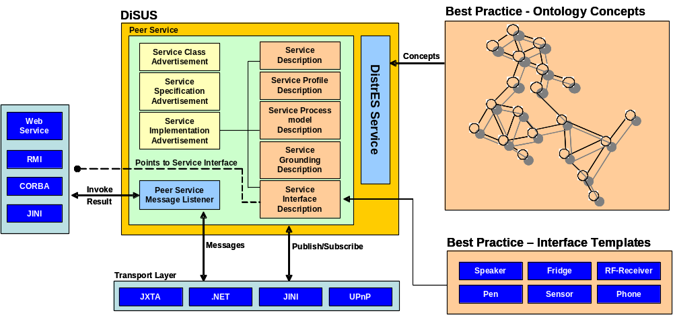
Figure x illustrates how semantic interoperability is performed using best practice repositories
  - Semantic Mark-up Language

Requests

Device requests

Service requests

Device Descriptions

Service Descriptions

Writing Service Descriptions

Discovery
  - Groups
  - Peer Groups
  - Discovery Mechanisms

Discovery Service

Message Service

Pipe Service

Semantic Service Capability Matching

Abstract Matching

Concrete Matching

Semantic Interoperability and Signature Matching

IOPE Matching

Signature Matching

Direct Matches

Indirect Matches

IOPE Conflict Resolution
  - Extended Interfaces

Control

Control

Event Handling
Using event models in standard Windows programming allows methods to be invoked when certain actions are preformed. For example each button on the user interface has an associated method containing specific code that runs each time the button is pressed. This model is well understood and easily implemented within standalone applications, however it becomes more difficult in distributed service oriented architectures. Typically such architectures communicate with each other via messaging and more importantly within P2P environments connections between services are connectionless. This model is similar to WWW interactions whereby messages are posted to a service and response messages are returned.
In such models an alternate model is required that supports event handling between distributed service usage. Fig. x illustrates a typical scenario within our framework. Peer A contains concrete service implementation, which it offers to the P2P network. It begins by start these services and then advertising them locally and within the peer group it belongs to by publishing a service advertisement for each service is provides. Peer B does not implement any core services, however it contains the standard core service interfaces used by concrete implementations. Peer B tries to find a remote service by first checking the Peers local cache to see if it has a specific advertisement for a specific service. In this instance a null value is returned to the peer indicating that it does not have an advertisement for the service request. Peer B tries to find the service by searching the Peer Group it belongs to. If the service exists an advertisement is returned and the peer creates an interface instance using the metadata contained in the advertisement. This instance results in a connectionless binding between Peer B and the remote service. This is achieved by using the endpoint information found within the advertisement that specifies where the service is located.
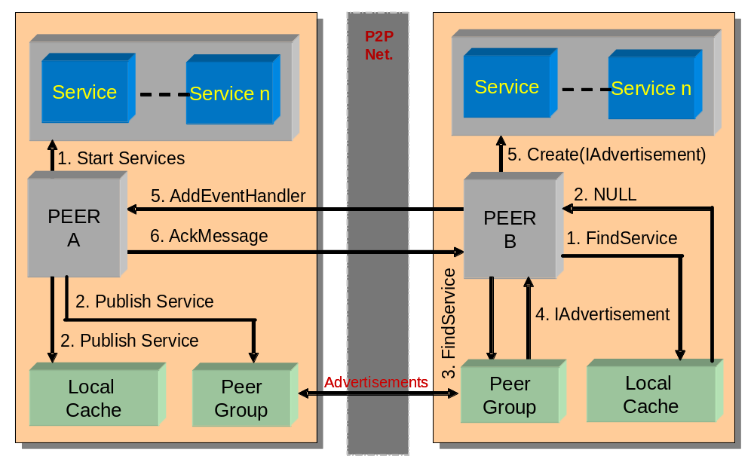
Figure x Adding event handlers for remote service usage
At this stage Peer B is only able to bind to the service and perform method invocations and process the results returned, however because of the connectionless binding mechanism Peer B does not know if the service is unavailable until a connection request is made and fails. Before Peer B uses the service it has the option to register itself as an Event Handler for the remote service. Peer B binds Peer A and sends a ‘addEventHandler’ message. This message contains the endpoint for Peer B, which is added to the collection of event handlers for the particular service. Because of the P2P nature we cannot guarantee that messages will be delivered. For example an overloaded peer may drop messages; therefore this type of message is asynchronous, which results in an ‘ack’ message being sent back to Peer B. If Peer B does not receive this message it will resend the message. If it still fails after three attempts the peer may chose to find an alternate service with a peer that is less congested.
In our framework peers that offer services must conform to simple network etiquette. Before Peer A un-registers a service it provides it must perform the following actions:
- It must announce that the service is being un-registered by sending an ‘un-registering service’ message to each endpoint contained in the event handler collection.
- Peer A must then destroy the service instance.
This allows Peer A and Peer B to destroy service instances so that they can be garbage collected enabling them to preserve method allocation. Furthermore it allows Peer B to dynamically find an alternate service unbeknown to the service user.

Synchronous Service Invocation

Asynchronous Service Invocation

Presentation
  - Design Requirements

REFERENCES

